**Database design of Cargo logistic system**

Xi Yu

CS6441

Part 2

1. System Data Flow Diagram

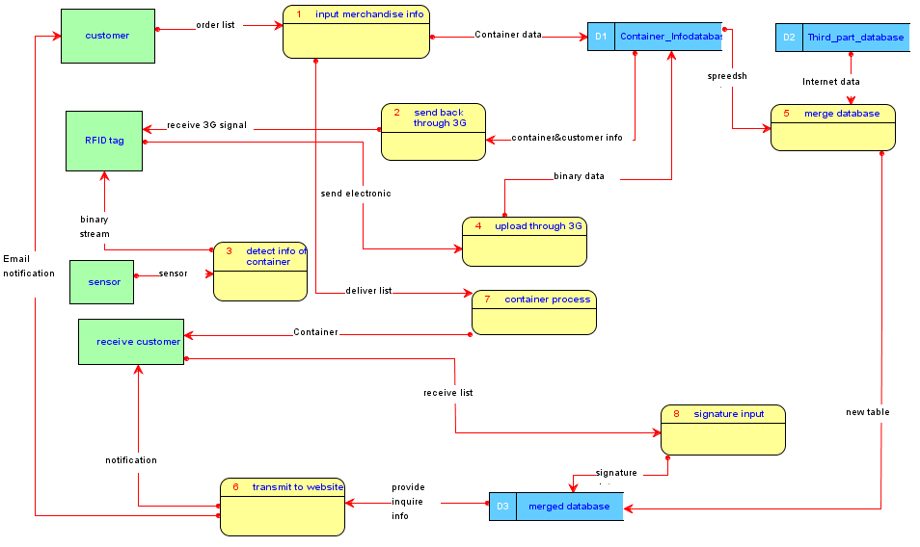

1. Entity Relationship Diagram

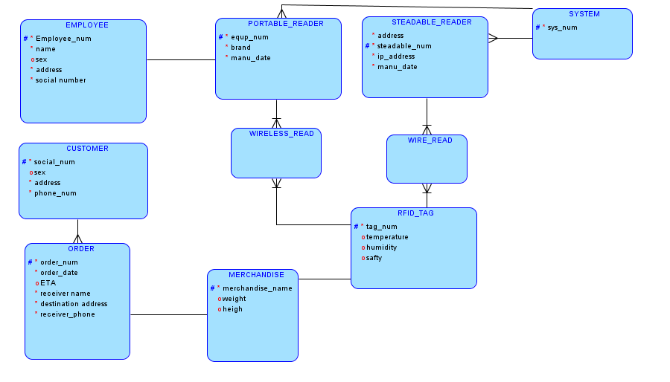

1. Major Entities and their descriptions
2. Employee

Staffs of company in charge of portable reader, each employee has their own information such as name and sex. The name of employee will be uploaded to System and showed to customers when the customers need to query.

1. Customer

Customers can send packages and receive packages. Customers use their ‘social_number’ as their primary key to make orders.

1. Order

One order can contain only one package. Orders have order data, estimated arrive time, mailing address and receiver name.

1. Portable_reader

Portable readers are used by employee. They use reader to trace packages state and safety. Portable readers could be carried by employee. It conveys information through Wifi and 3G net.

1. Stationary_reader

Stationary readers are fixed on location. When truck loading packages passes special location which installed stationary readers, the readers will record RFID tags on packages. They are the same actions as portable readers.

1. RFID_tag

RFID tag records state of packages such as humidity and temperature. If packages are opened without authorization, the RFID tag will record that and alert to reader when readers read information next time.

1. Merchandise

This could be packages, containers, etc. Customers send merchandise to another person.

1. System

The whole software contains other information such as databases and analysis system. These parts are not emphasis of this project, so I used system to generalize them.